Raspberry Pi Setup

# Change History

|  |  |  |  |  |
| --- | --- | --- | --- | --- |
| Version |  | Author | Date | Description |
| 0.1 |  | Adrian Gfeller | 22.05.2017 | Initial Draft |
| 1.0 |  | Walter Rothlin | 20.07.2017 | Updated |
| 1.1 |  | Benjamin Raison | 22.09.2017 | Fixed erros, formatting, replaced apt-get with apt where possible, added “Installing Apache” |
| 1.2 |  | Walter Rothlin | 23.09.2017 | Updated example to python 3 |
| 1.3 |  | Benjamin Raison | 28.09.2017 | Added Perl CGI + example, added instructions on sensor input errors |
| 1.4 |  | Benjamin Raison | 09.10.2017 | Added section on discovering the IP address & Pi Plates |
| 1.5 |  | Walter Rothlin |  | Set-UP WiFi an BSU |
| 1.6 |  | Walter Rothlin | 29.11.2017 | Web-Server Config |
| 1.7 |  | Walter Rothlin | 14.06.2019 | CGI Config |
| 1.8 |  | Walter Rothlin | 06.03.2021 | Added Remote-Access |

Contents

Change History 1

Download OS for Raspberry 3

Write Image to SD-Card 4

First startup 4

Boot & Login 4

Changing the Keyboard Layout 5

Changing the Password 6

Connecting to internet 7

Via Desktop 7

Via cable 8

Via Wi-Fi (via Command line) 10

Via BZU Wi-Fi 10

Wi-Fi set-up using desktop 11

Updating the System 12

Enable On-Board-Screen 12

Enable SSH 12

Save the Image of the Raspberry Pi 13

Remote-Access 14

Google VNC 15

Remote Desktop with Xming and Putty 16

ssh using PuTTY 17

nppFTP plugin for Notepad++ 17

SFTP via FileZilla 18

Pi Plates 19

Addressing the boards 19

Further documentation 19

Installing Apache 20

Enable CGI 20

Enable Sense-Hat and PiPlates for CGI calls 21

Change Web-Server to run the scripts as user pi (not mandatory) 21

Perl example 22

Troubleshooting 22

# Download OS for Raspberry

In this guide, *Raspbian* will be used which is a Linux distribution based on Debian and targeted at Raspberry Pi. Raspbian comes in to versions: DESKTOP and LITE.

Download the latest *Raspbian Jessie Lite* from <https://www.raspberrypi.org/downloads/raspbian/> (20.7.2017)

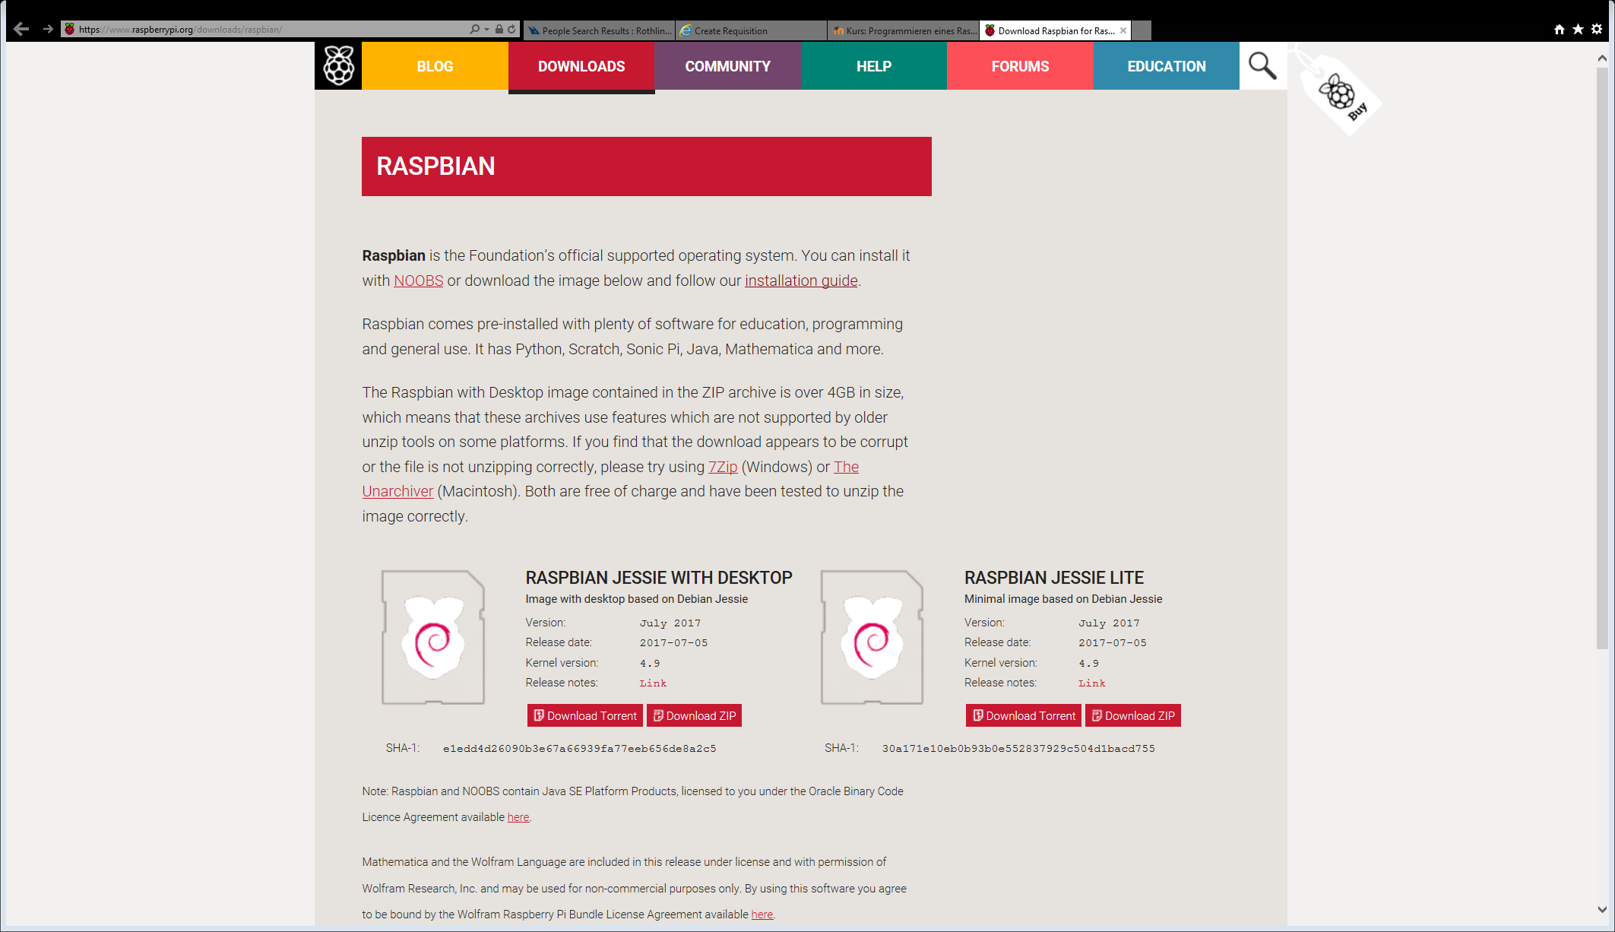

After the download has finished, extract the zip folder to get to the image file.

# Write Image to SD-Card

The following information is extracted from <https://www.raspberrypi.org/documentation/installation/installing-images/README.md> and <https://www.raspberrypi.org/documentation/installation/installing-images/README.md> which is linked on the download page.

Install Win32DiskImager from <https://sourceforge.net/projects/win32diskimager/> (20.07.2017)

Insert the SD Card into the PC (Via integrated card reader or an adapter)

If you have to format it use FAT32.

Run Win32DiskImager.exe and finish the installation.

Run the program and set the Image to the previously extracted .img file and select the drive letter. Be careful with selecting this letter as you can lose data when you’re choosing the wrong one.

Then click on Write

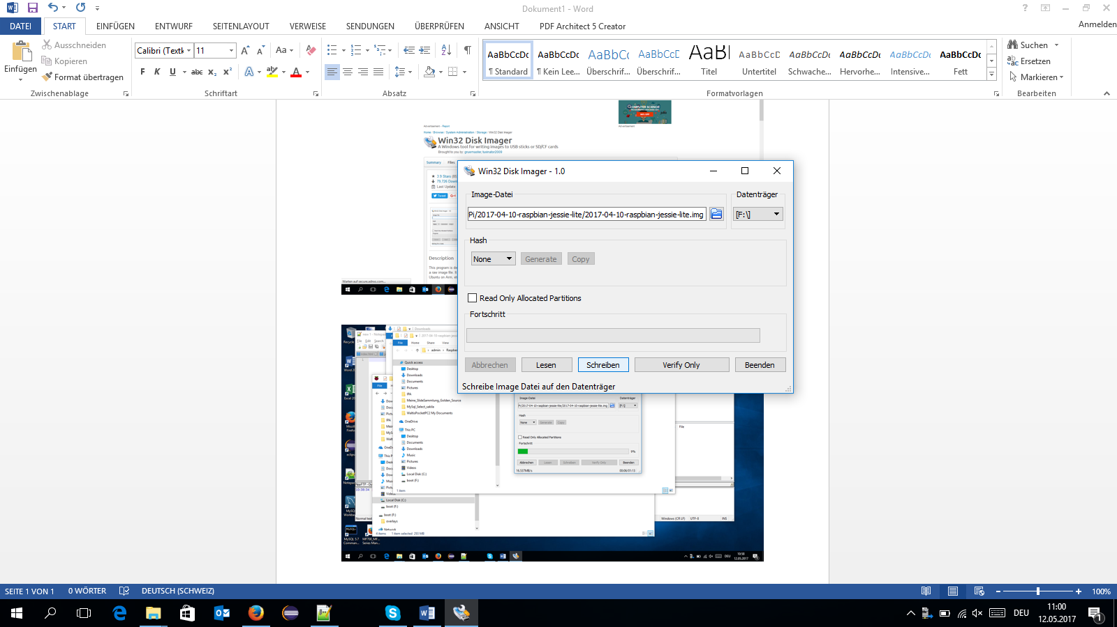

The SD Card is now ready to be inserted into the Raspberry Pi

# First startup

## Boot & Login

Insert the SD-Card into the Raspberry Pi, plug in an HDMI Cable and provide it with power over a MicroUSB cable.

You’ll be logged in automatically and will be presented with the desktop.

Don’t connect to internet yet!!! Your Pi is totally unsecured at the moment.

The first and most important step is to change at least the password because the whole world knows it at this moment and as soon as you’re connected to the internet, everyone is able to get access to your Raspberry Pi.

But before that step, we need to make sure that our keyboard layout is matching our keyboard. Otherwise you’ll enter your password wrong and can’t log in when the layout changes.

In case you’re not automatically logged in:

raspberrypi login (username): **pi**  
Password: **raspberry** (type “*z*“ instead of ”*y*“ because of UK keyboard layout)

## Changing the Keyboard Layout

Run raspi-config by opening the *Start Menu* and then *Preferences* > *Raspberry Pi Configuration*

Navigate to the *Localisation* Tab and click on *Set Keyboard…*

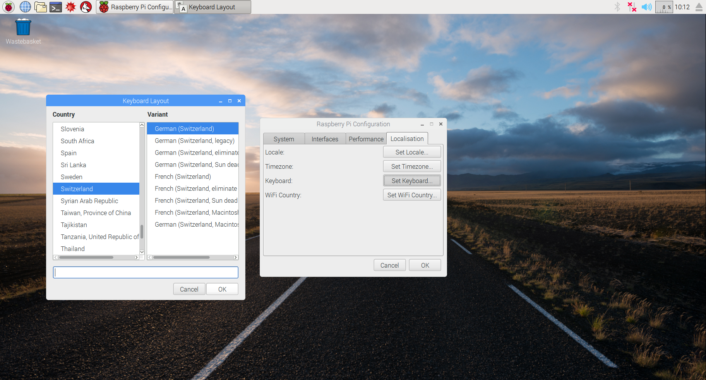

Another Window should pop-up. Select *Switzerland* and *German (Switzerland)* / whatever is matching the keyboard layout. Then click *OK*. After this the layout has already changed.



## Changing the Password

Again, in the Raspberry Pi Configuration, activate the *System* Tab and click on the *Change Passwor…* button:

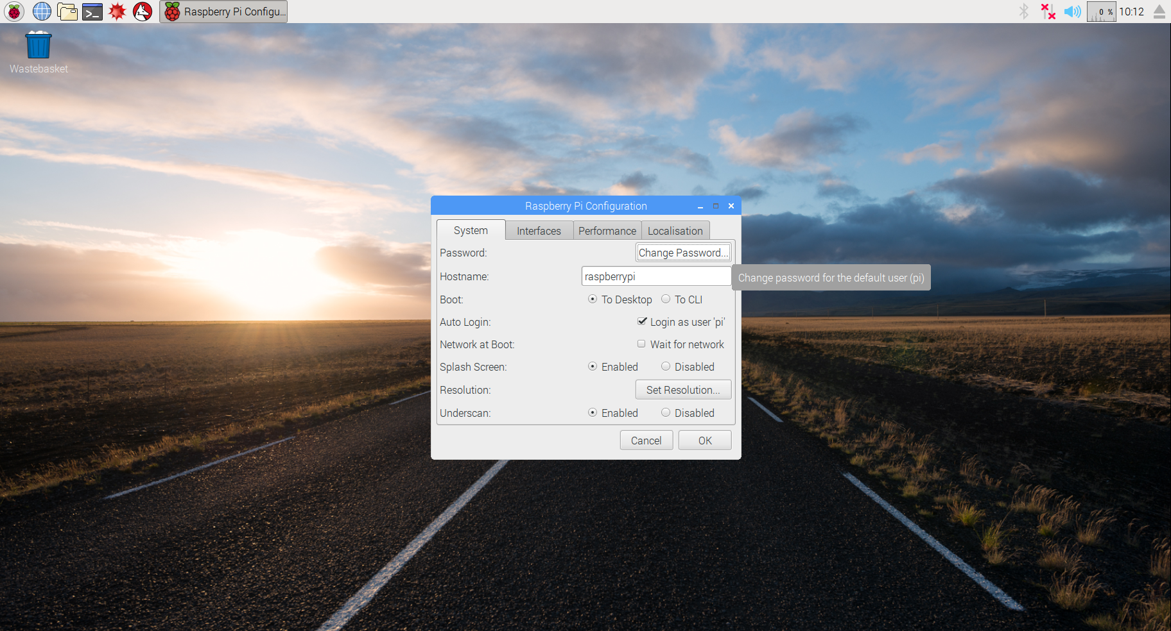

As *Current password* enter **raspberry** then assign a new one; two times to confirm. Then click on *OK*.

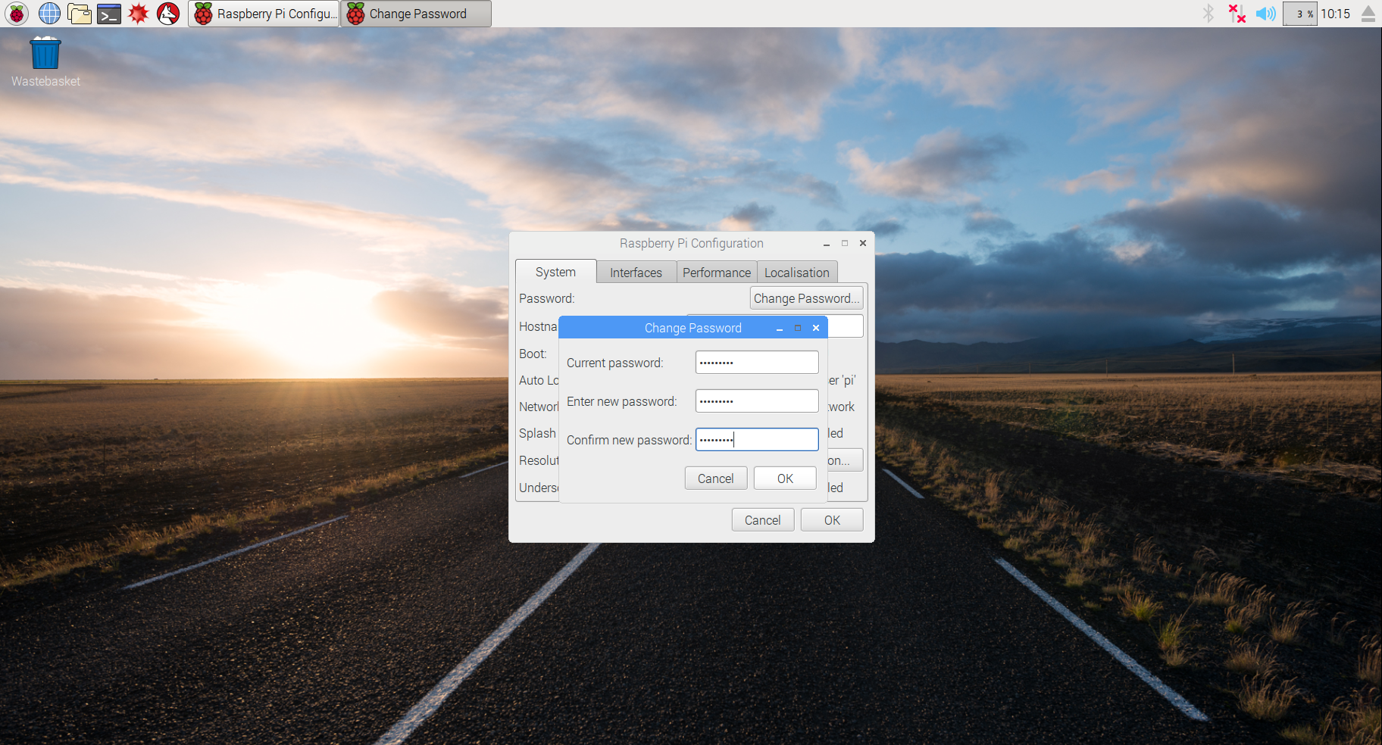

# Connecting to internet

## Via Desktop

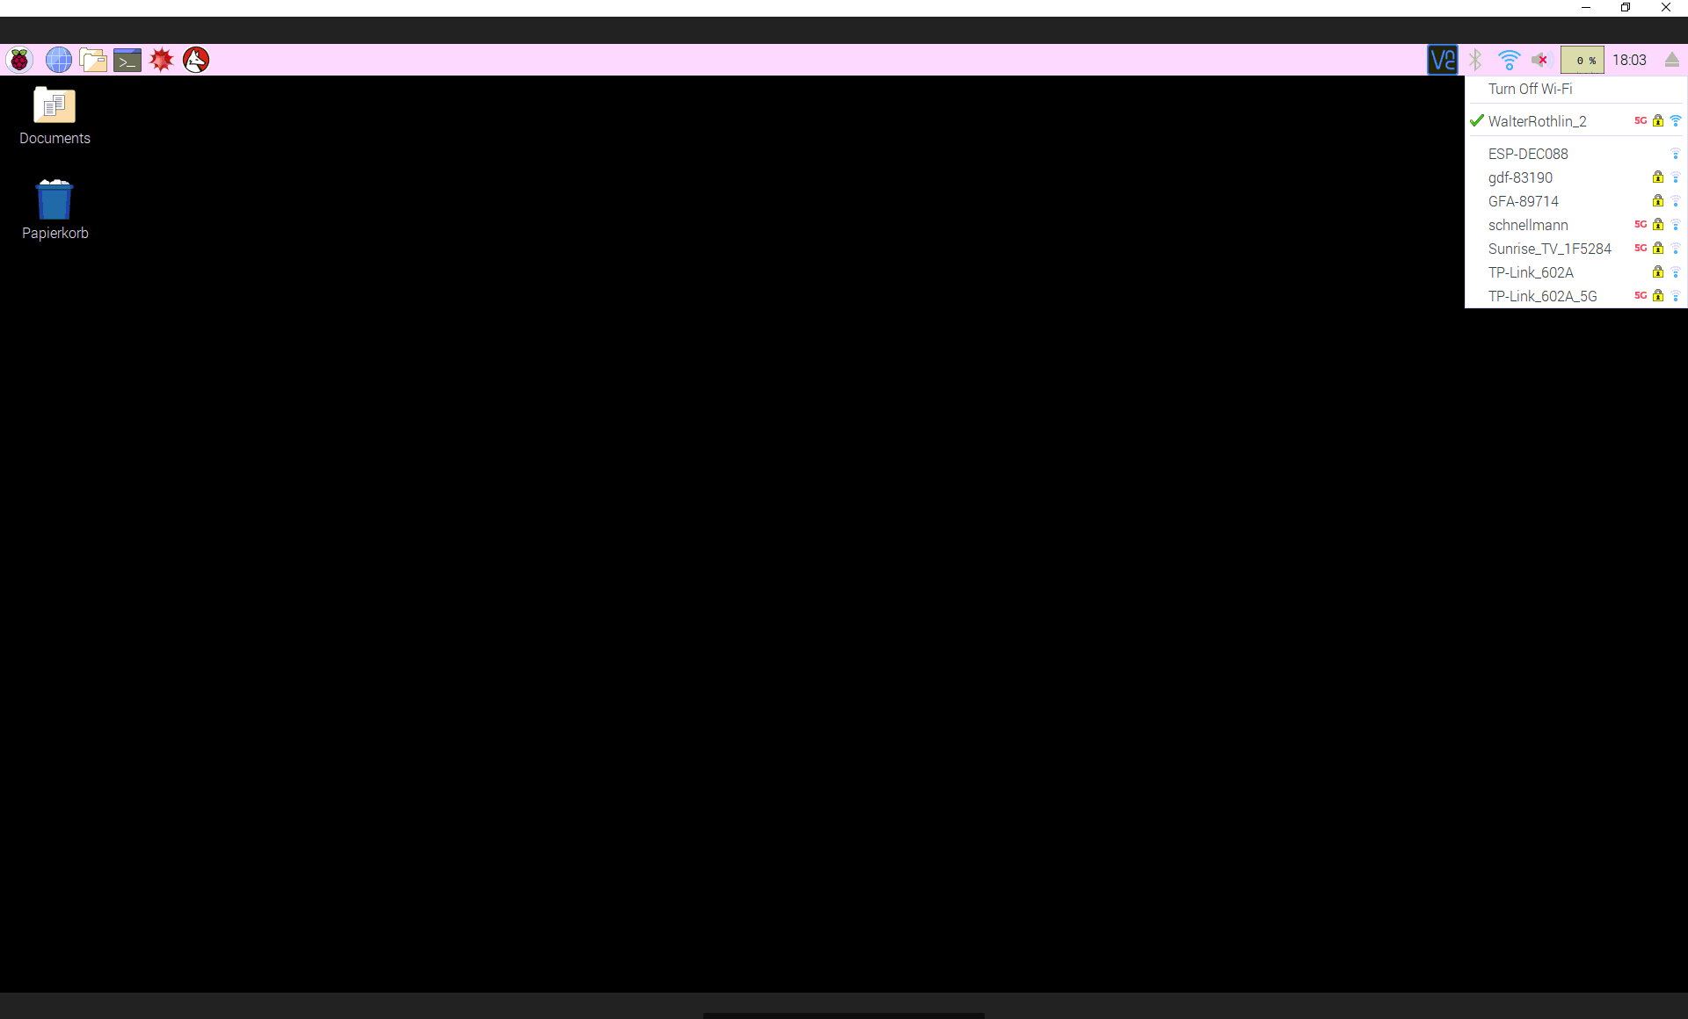

## Via cable

This is easy: Just plug the cable into the Pi and the router will assign an IP address to the Pi.

Should you be unable to access the internet, do the following (on Windows):

Navigate to the control panel and open “Network Connections”

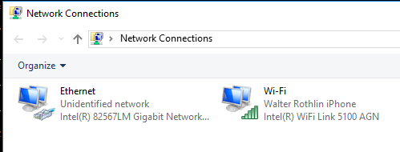

Select the network you already have an internet connection on and open the properties.

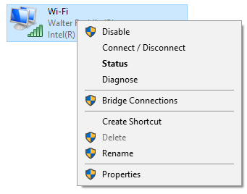

Then, open the “Sharing” tab and check both boxes, then OK.

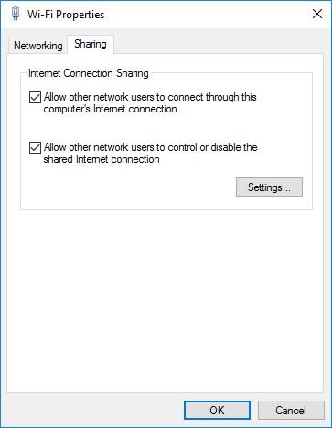

Then restart the Raspberry Pi.

If you don’t know the IP address of the Raspberry Pi, run the following command on the host computer: 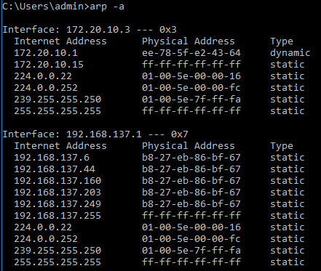

Then try all IP addresses where the “Physical Address” starts with **b8-27-eb**. On of them will be the Rasperry Pi.

## Via Wi-Fi (via Command line)

Raspberry 3 Model B has on board WIFI otherwise plug in a WIFI dongle into a USB port of the pi.

sudo nano /etc/wpa_supplicant/wpa_supplicant.conf

network={

ssid="Walter Rothlin iPhone"

psk="testingPassword"

}

Detail description under:  
<https://www.raspberrypi.org/documentation/configuration/wireless/wireless-cli.md>  
  
sudo iwlist wlan0 scan # this command will list all available networks

## Via BZU Wi-Fi

1. In der datei : /etc/wpa_supplicant/wpa_supplicant.conf folgendes einfügen (benutzername und passwort auf ihres abändern! )
   1. Mit sudo nano /etc/wpa_supplicant/wpa_supplicant.conf
2. network={  
           ssid="BZU"  
           proto=RSN  
           key_mgmt=WPA-EAP  
           pairwise=CCMP  
           auth_alg=OPEN  
           eap=PEAP  
           identity="vorname.nachname"  
           password="ihrbzupasswort"  
           phase2="auth=MSCHAPV2"  
   }
3. Dann führen sie noch folgende 3 Befehle aus:
   1. root@raspberrypi:~# wpa_cli reconfigure   // lädt die Konfigurationsdatei neu
   2. root@raspberrypi:~# sudo ifconfig wlan0 up // setzt das wlan0 device auf aktiv
   3. root@raspberrypi:~# ifconfig wlan0 // hier sollten sie nun eine IP Adresse sehen

Damit das ganze automatisch funktioniert, ändern sie die folgende Zeile in /etc/network/interfaces:

iface wlan0 inet manual  
auf:  
iface wlan0 inet dhcp

## Wi-Fi set-up using desktop

Raspberry 3 Model B has on board WIFI otherwise plug in a WIFI dongle into a USB port of the pi.

sudo nano /etc/wpa_supplicant/wpa_supplicant.conf

network={

ssid="Walter Rothlin iPhone"

psk="testingPassword"

}

Detail description under:  
<https://www.raspberrypi.org/documentation/configuration/wireless/wireless-cli.md>  
  
sudo iwlist wlan0 scan # this command will list all available networks

# Updating the System

First thing after connecting to the internet, is to update all the software and performing possible kernel-updates. This will ensure, that known bugs or security holes are fixed.  
This is done with these two apt-get commands:

sudo apt update # list all the modules which will be upgraded (doesn’t perform an change on the system)

sudo apt upgrade

The sudo apt autoremove command can be issued to remove unnecessary package files.

# Enable On-Board-Screen

Information extracted from the **Tontec MZ61581** setup guide.

Open /boot/config.txt

sudo nano /boot/config.txt

And add these lines to the bottom

dtparam=spi=on

dtoverlay=mz61581

Then save and reboot  
Here we will change the default output display from HDMI to Tontec Screen

sudo nano /usr/share/X11/xorg.conf.d/99-fbturbo.conf

Change  
 Option "fbdev" "/dev/fb0"  
To

Option "fbdev" "/dev/fb1"

If you want to switch back to the HDMI display, just change it back to **fb0**

# Enable SSH

Open up the Raspberry Pi Config again and navigate to the *Interfaces* Tab.

There activate the SSH service.

# Save the Image of the Raspberry Pi

Create a new file with an *.img* extension somewhere on your PC.  
Eject the SD-Card from you Raspberry Pi and plug it into your computer.

Open up Win32DiskImager and for the image file select the empty one you’ve created before. Select the correct drive letter where the SD-Card is mounted and then click on *Read* / *Lesen*.

# Remote-Access

Sobald der Raspberry am Netz hängt (via WiFi oder LAN) kann Remote darauf zugegriffen werden. Dazu ist wichtig, die IP Adressen zu kennen.

IP-Adresse Raspberry: ifconfig

IP-Adresse Desktop: ipconfig

a) Remote-Shell

Eine ssh Session vom Desktop zum Raspberry via PuTTY kreieren.

Damit können Commands abgesetzt und ASCII basierte Resultate angezeigt werden

Mit fire-ftp (Firefox plugin) oder Notepad++ (NPP FTP Plugin) können Files verschoben werden

Es ist wichtig je nach File-Type den Transfer-Mode (BIN/ASCII) zu beachten!

b) X11 Redirect (X11 ist das Windowing System auf Linux / UNIX)

X-Server:Desktop / Windows-Computer

X-Client: Remote-System, in unserem Fall der RaspberryPi

Auf dem Desktop ein X-Server starten (z.B. XMing), Es wird nichts sichtbar!

Eine ssh Session vom Desktop zum Raspberry via PuTTY kreieren

In der ssh Session folgendes auf dem Raspberry vorbereiten:

sudo raspi-config

Started config menu in Ascii Mode

Menu 5 / P3 VNC Enable X forwarding

----------------------------------------------------------------------------

xhost+

Erlaubt, dass X11-Windows auf einem anderen Rechner (X-Server) angezeigt werden können

----------------------------------------------------------------------------

export DISPLAY=192.199.18.1

X11-Windows werden auf 192.199.18.1 (X-Server) umgeleitet / geöffnet

----------------------------------------------------------------------------

lxsession &

Starten der Windows-Oberfläche remote (Display umgeleitet via IP)

----------------------------------------------------------------------------

Sobald Sie Remote auf den RaspberryPi zugreifen können, können Sie z.B. Notepad++ mit dem NPP-FTP Plugin verwenden und dann die Files direkt auf dem RaspberryPi von ihrem PC aus editieren.

In Python gibt das Einrücken die Struktur des Programms vor. Ich empfehle, im Notepad++ unter Setting --> Preferences... -> Language resp. TAB Settings dies entsprechend einzustellen, so dass z.B. bei der Eingabe eines TAB 4 Spaces eingeführt werden.

## Google VNC

Run google-Chrome and start VNC

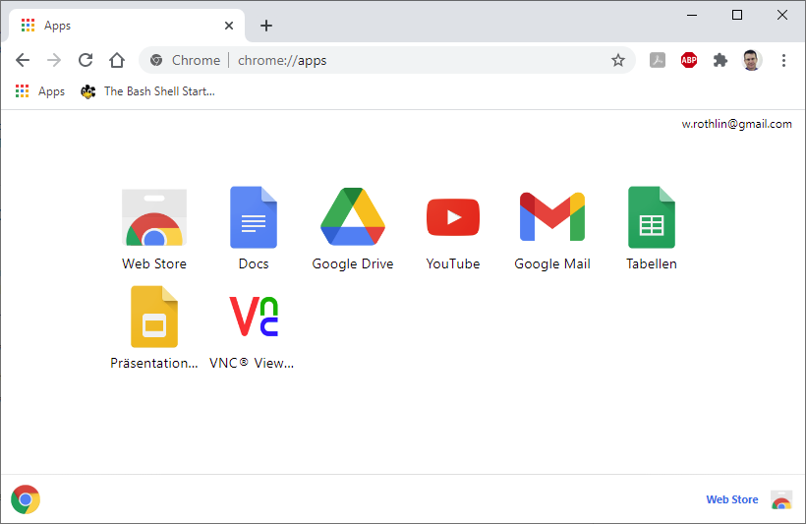

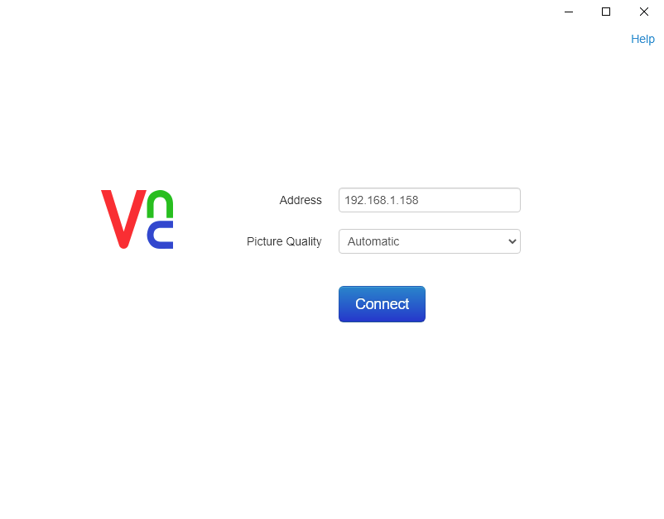

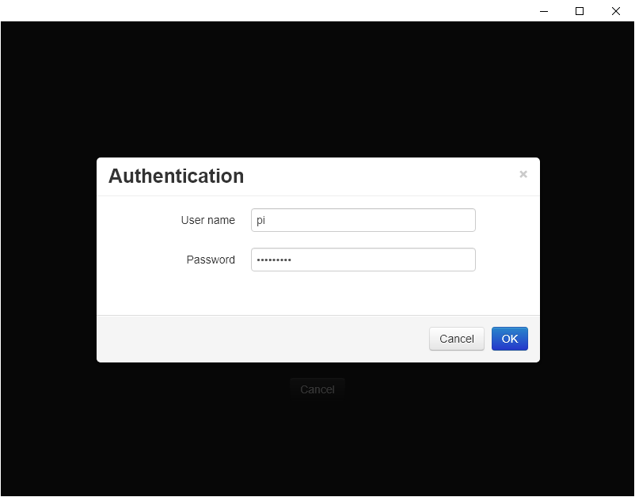

## Remote Desktop with Xming and Putty

1. Download and Install Xming <https://sourceforge.net/projects/xming/>
2. Execute XLaunch
3. Choose “Fullscreen”  
   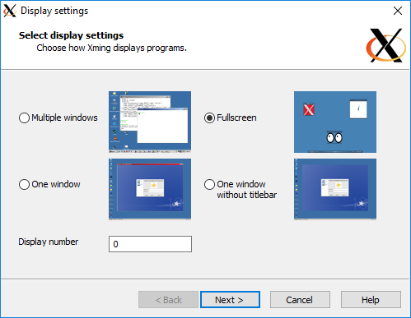
4. Press Enter multiple times until the window closes  
   A new window should open in fullscreen
5. Tab out and go to Putty
6. Load your connection (not open!)
7. Go to **Connection -> SSH -> X11**, enable X11 forwarding and set X display location to “localhost:0”  
   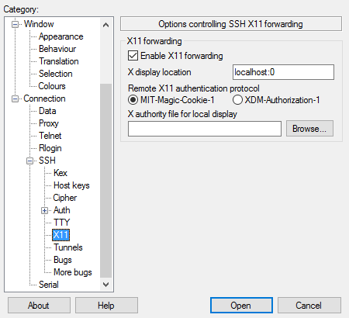
8. Save your connection
9. Open your connection
10. In the terminal, type “**startlxde**” and press Enter
11. After a short while, it should switch to Xming and start displaying the desktop.

## ssh using PuTTY

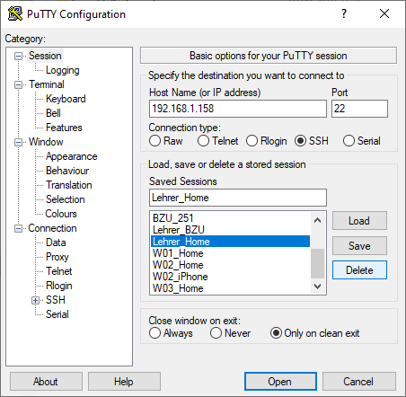

## nppFTP plugin for Notepad++

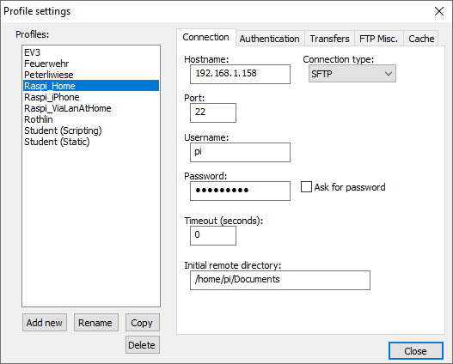

## SFTP via FileZilla

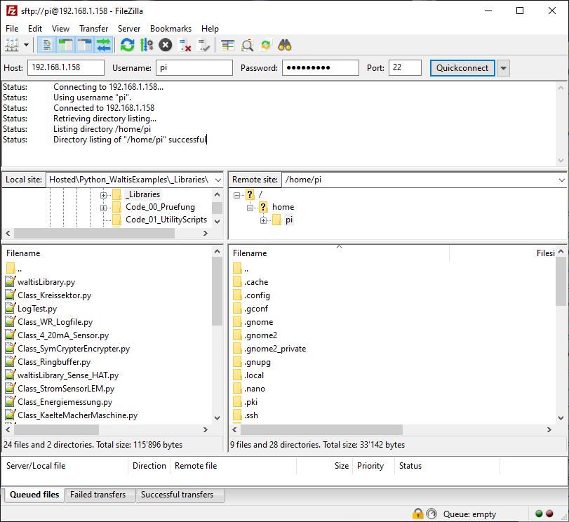

# Pi Plates

Run **sudo raspi-config** and enable **SPI** under **Advanced**

Then reboot and run one of the following commands:

sudo pip install pi-plates #Python < 3

sudo pip3 install pi-plates #Python >= 3

You can now use your Pi Plates.  
Should your program complain about missing libraries, install them with **pip(3)** or **apt.**

Example programs can be found in ~/Documents/PythonExamples/Code_06…

## Addressing the boards

Each plate in the stack must have a unique address. The address is set as seen in the image below. The address is only read at boot time, so you have to restart the Raspberry Pi to change the address of a plate.

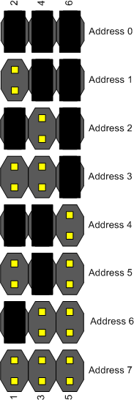

## Further documentation

For complete documentations, refer to <http://pi-plates.com/documentation>

# Installing Apache

This will guide you in setting up a running webserver able to show both HTML pages and run Python scripts

Run the following command to install the webserver:

sudo apt install apache2

Enter the IP of your Raspberry Pi into a web browser to see if it works.

## Enable CGI

Create a cgi-directory:

sudo mkdir /var/www/cgi-bin/

Create file /var/www/cgi-bin/test.py with the following content:  
The empty line is important. It separates the headers from the body.

#!/usr/bin/python3

print(“Content-Type: text/html”)

print()

print(“Hello World!“)

Change apache config:  
  
  
Add the following at the end of the config-file:

sudo nano /etc/apache2/apache2.conf

AddHandler cgi-script .cgi .py .pl

Then, look for something like this:  
  
and add the following block:  
  
  
Save and exit the file. Then, run the following commands:

<Directory /var/www>

Options Indexes FollowSymlinks

ScriptAlias /cgi-bin/ "/var/www/cgi-bin/"

<Directory /var/www/cgi-bin>

Options Indexes FollowSymLinks ExecCGI

AllowOverride None

Require all granted

</Directory>

sudo a2enmod cgi

sudo service apache2 restart

Open [you-ip-here]/cgi-bin/test.py in your web browser.

Check log-file for Errors:

sudo tail -f /var/log/apache2/error.log

## Enable Sense-Hat and PiPlates for CGI calls

Execute the following commands as root:

# Add apache to input group

sudo adduser www-data input

sudo adduser www-data kmem

sudo adduser www-data spi

sudo adduser www-data i2c

sudo adduser www-data gpio

If the sense HAT gives a “permission denied” error, run the following command to copy the sense hat config file to the apache home directory:

sudo mkdir /var/www/.config

sudo cp –r /home/pi/.config/sense_hat /var/www/.config

Now restart the Raspberry Pi. After that, your script should be able to read sensor data over the webserver.

## Change Web-Server to run the scripts as user pi (not mandatory)

(instead of www-data):

sudo nano /etc/apache2/envvar

Replace www-data by pi (twice)

Change Document-Root: /etc/apache2/sites-available/000-default.conf and change DocumentRoot from /var/www/html to whatever you like

## Perl example

The following is a perl script that outputs the request headers.

If you have not setup python yet, do that first.

Create /var/www/html/test.pl and enter the following:

#!/usr/bin/perl

use strict;

use warnings;

use CGI;

my $q = CGI->new;

my %headers = map {$_ => $q->http($_)} $q->http();

print $q->header(‘text/plain’);

print “Got the following headers:\n”;

for my $header (keys %headers) {

print “$header: $headers{$header}\n”;

}

Open [your-ip-here]/test.pl in a web browser.

## Troubleshooting

For anything to do with the webserver, error logs can be found at **/var/log/apache2/error.log**

Complete the following steps if you need to use sense_hat:

Execute the following commands as root:

# Copy configuration

cp /root/.config/sense_hat_RTIMULib.ini var/www/.config/sense_hat/RTIMULib.ini

# Create udev rules to allow access

touch /etc/udev/rules.d/99-i2c.rules

Into the file you created, paste the following:

KERNEL==”i2c-[0-7]”,MODE=”0666”

sudo mkdir /var/www/.config

sudo cp –r /home/pi/.config/sense_hat /var/www/.config

Now restart the Raspberry Pi. After that, your script should be able to read sensor data over the webserver.